Dementia revisited
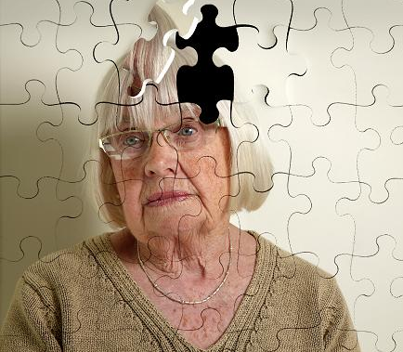
TASK 1 - Symptoms Prevention

Task 2 - Normal memory loss or signs of dementia? (Put NM or D next to each)
- They forget names or appointment.
- They can’t remember why they came into a room.
- They forget recently learned information.
- They can’t remember the right word for an everyday object.
- They can’t remember how to use a phone or play a game.
- They use the wrong word to describe something.
- They forget what day of the week it is.
- They put clothes that don’t go together.
- They put on unsuitable clothes.
- They feel sad or moody
- They keep losing things
- They seem less interested in their personal hygiene

Task 3 - Helping a person with dementia
Problem | Advice
Bathing and personal hygiene
Dressing
Toileting and incontinence
Cooking
Eating
Driving
Alcohol and cigarettes
Sleeping
Theft (by them or from them)
Wandering

